Our books
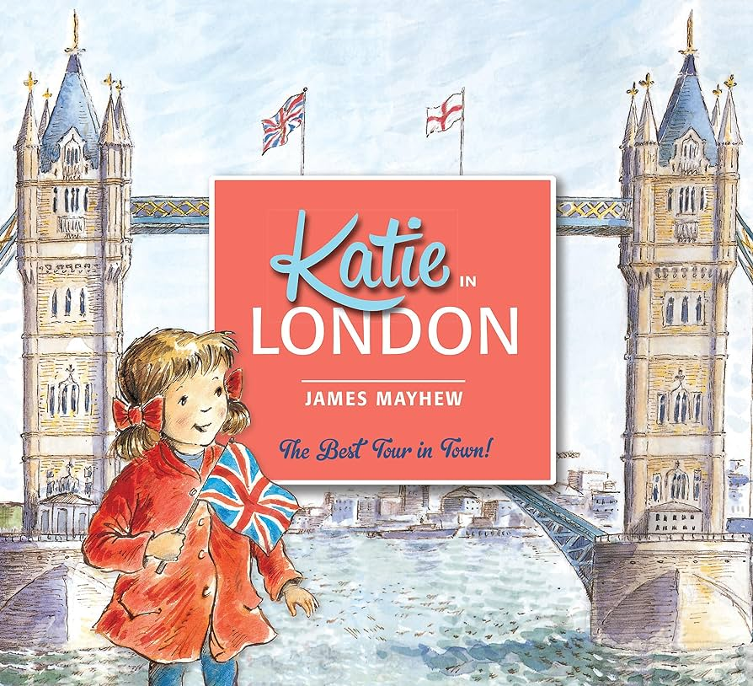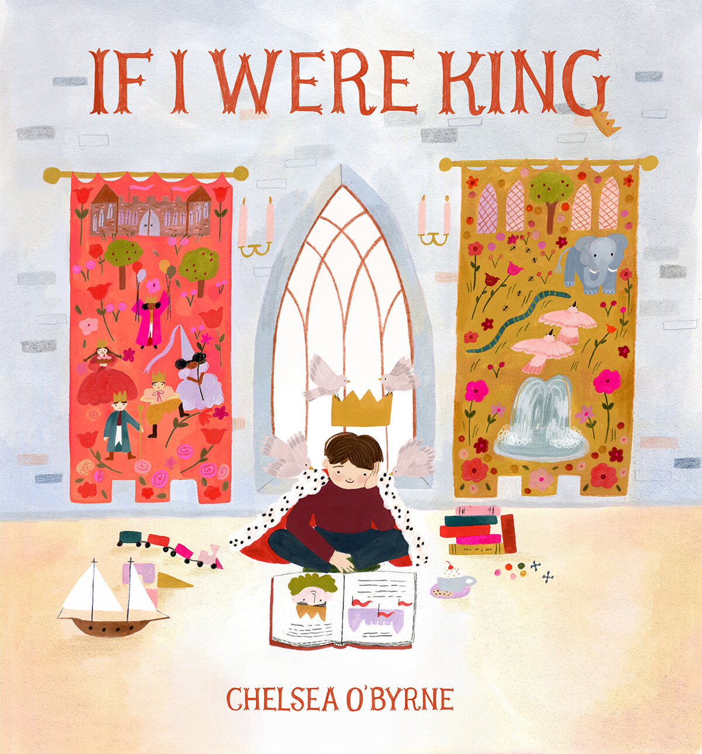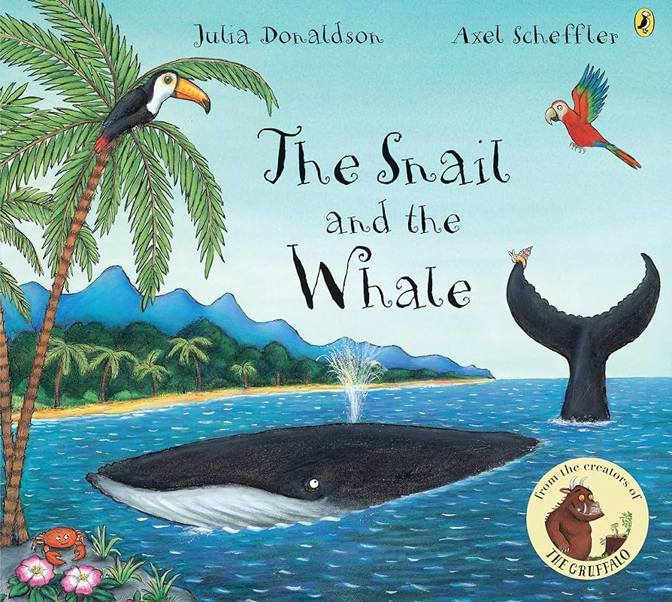

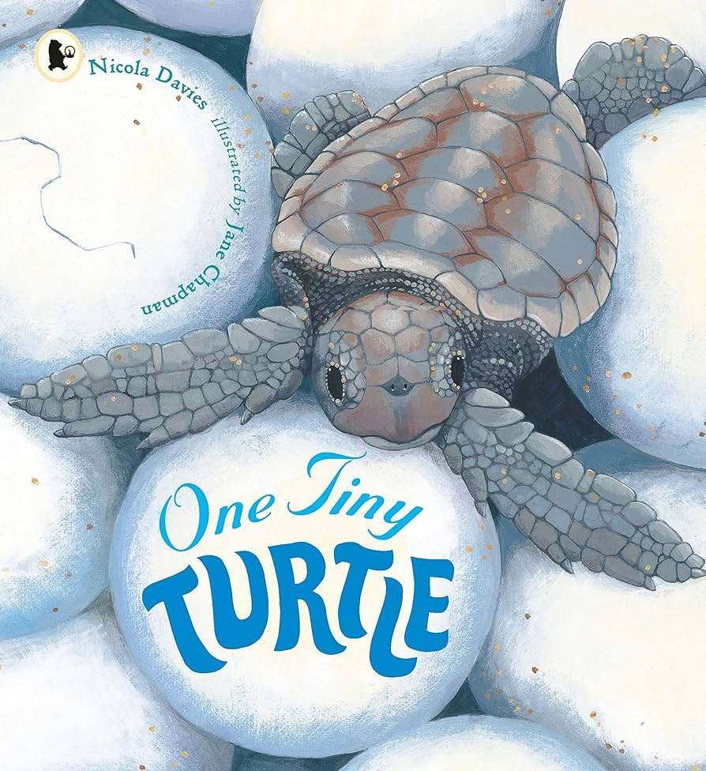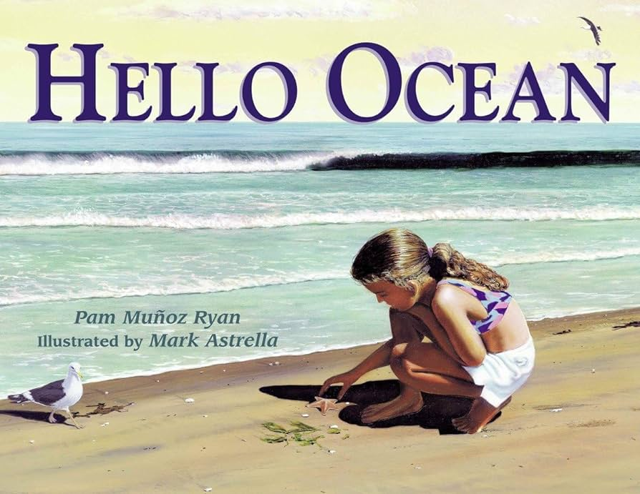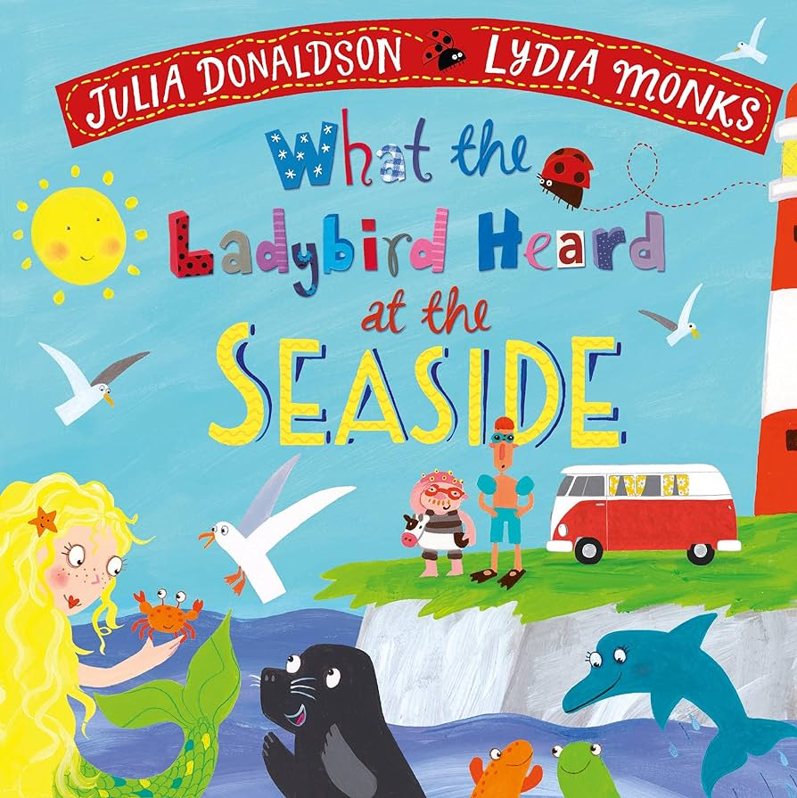

Knowledge Organiser – London and Holidays - Summer 2 2025
Key Facts and Knowledge

To know that London is the capital of England.
To name London landmarks and use a map.

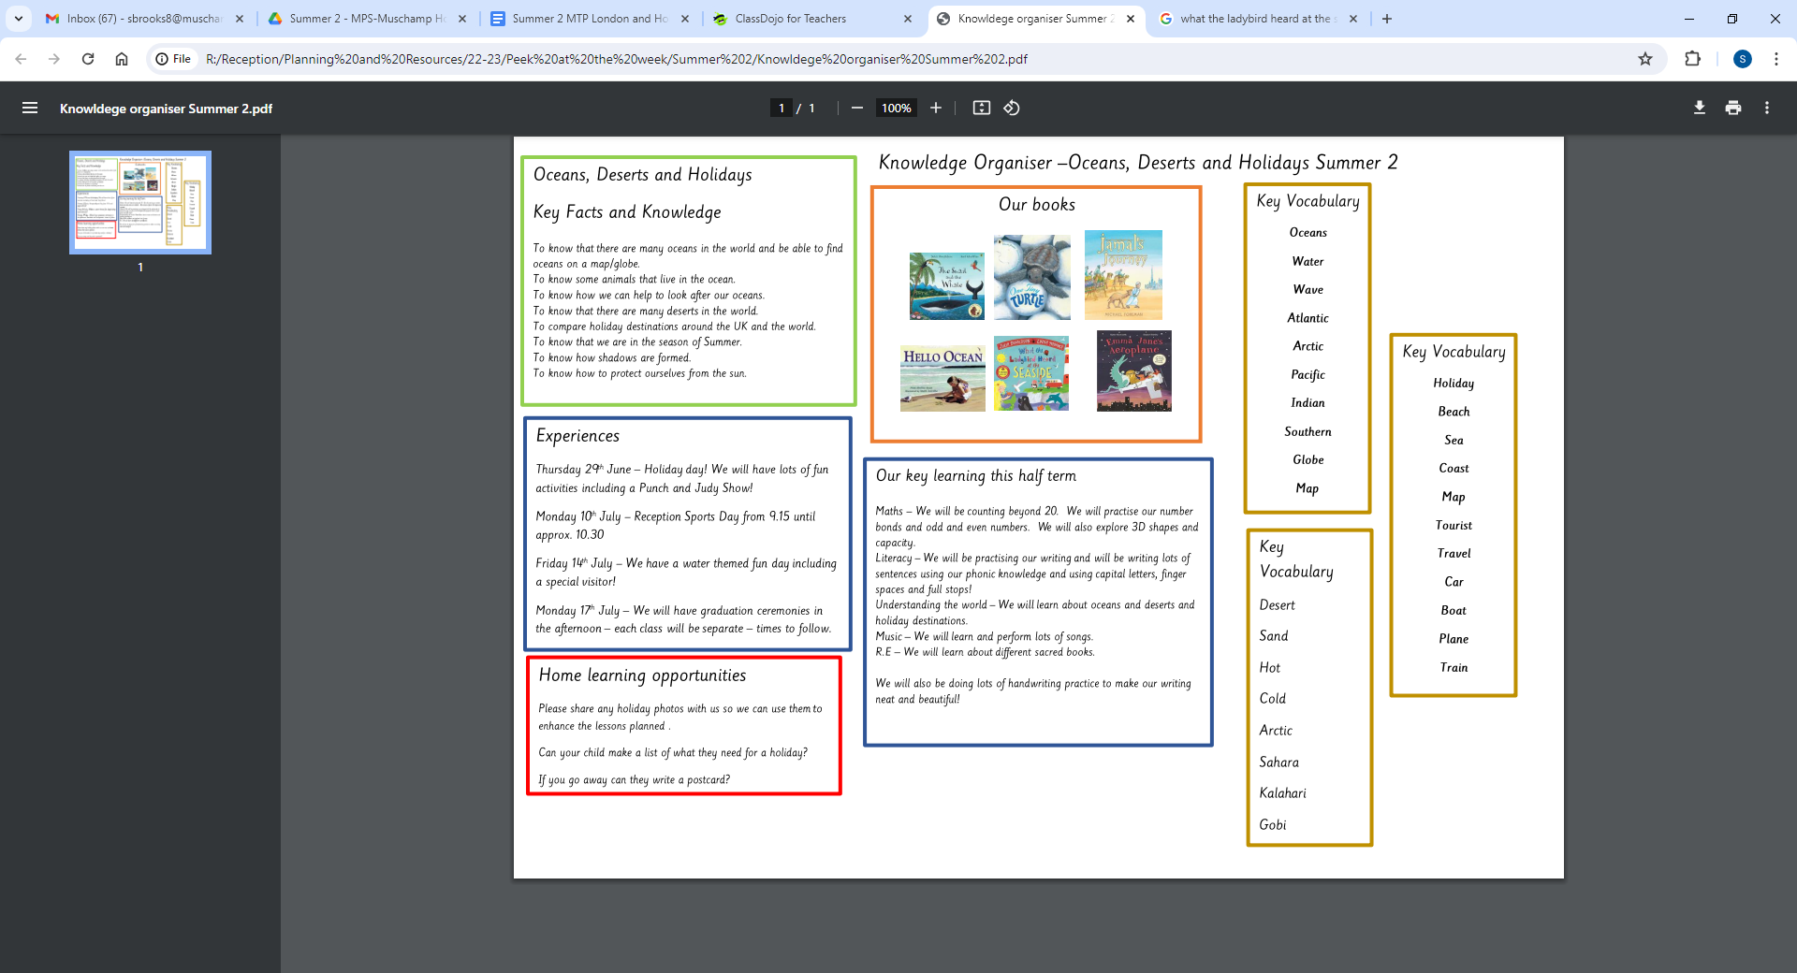

Key Vocabulary –London
bus, London, river,
Big Ben, London Eye, Nelson’s Column,, Buckingham Palace, Tower Bridge, Shard, St Pauls Cathedral landmark, bridge
symbol, key

crown, king, monarch, royal

Key Vocabulary
water, snail, whale
oceans, map, globe,
Atlantic, Arctic, Pacific, Indian, Southern

Pollution
ocean, map, holiday, beach, sea
tourist, travel, suitcase, luggage
destination, traditional, Punch and Judy

Experiences
Punch and Judy show
Sports Day – 8th July

Our key learning this half term

Maths – We will be learning about teen numbers and ordering numbers to 20. We will be practising our doubling and halving and number bonds.
Literacy – We will be practising writing labels, captions and sentences.
Understanding the world - We will learn about London, oceans and holiday destinations.

Home learning opportunities
Please share any photos from London and any holiday photos.

