Changes
Key Knowledge –
To know the life cycle of a plant and a butterfly
To talk about changes in materials.
To know the names of minibeasts.
To identify changes since starting Nursery.
To know that there are different countries in the world.

Our stories this term
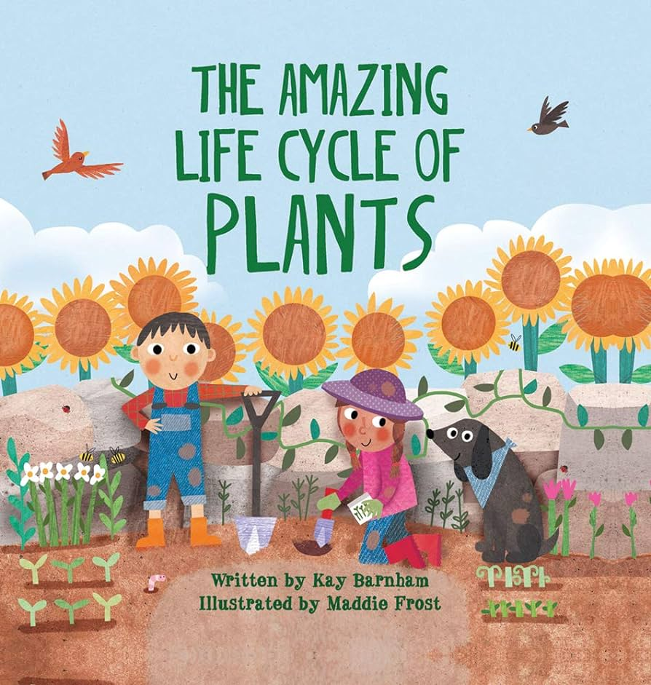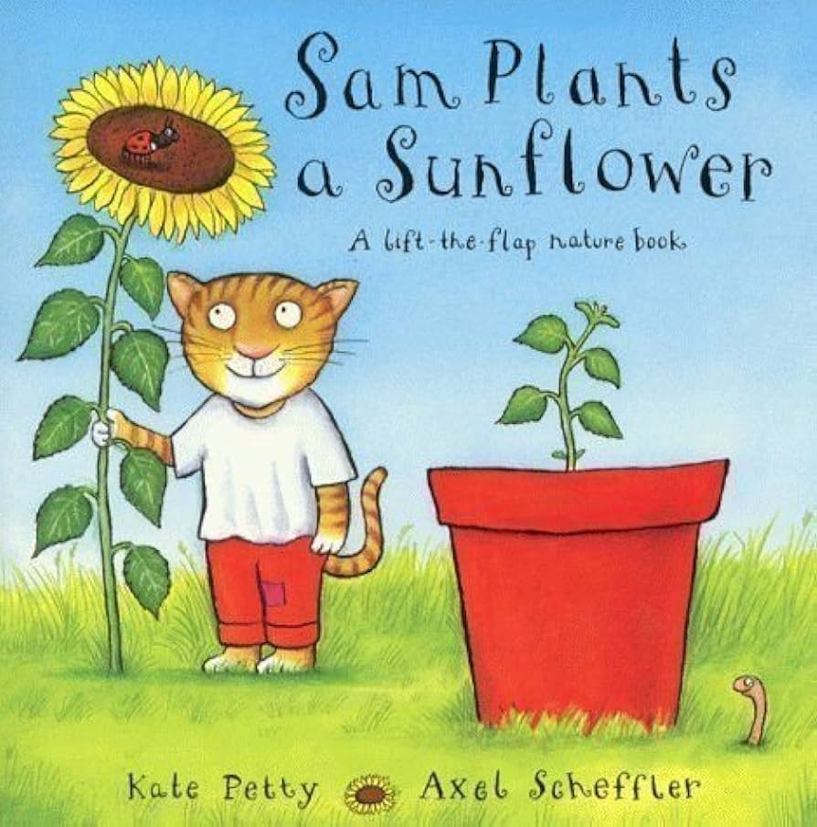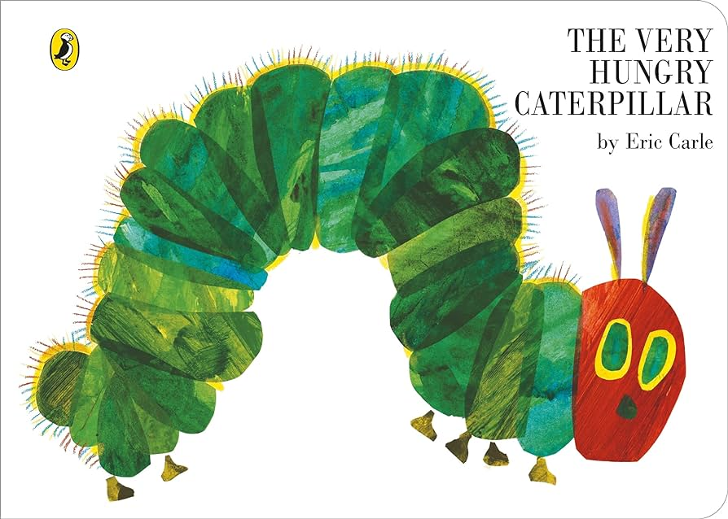
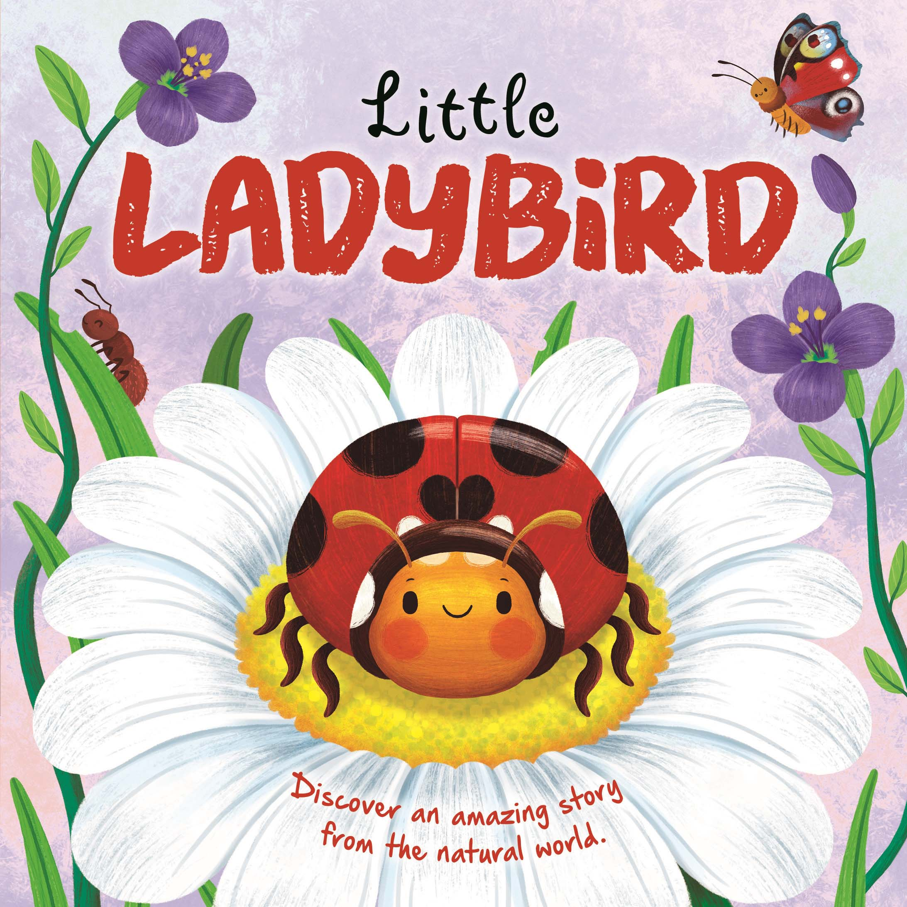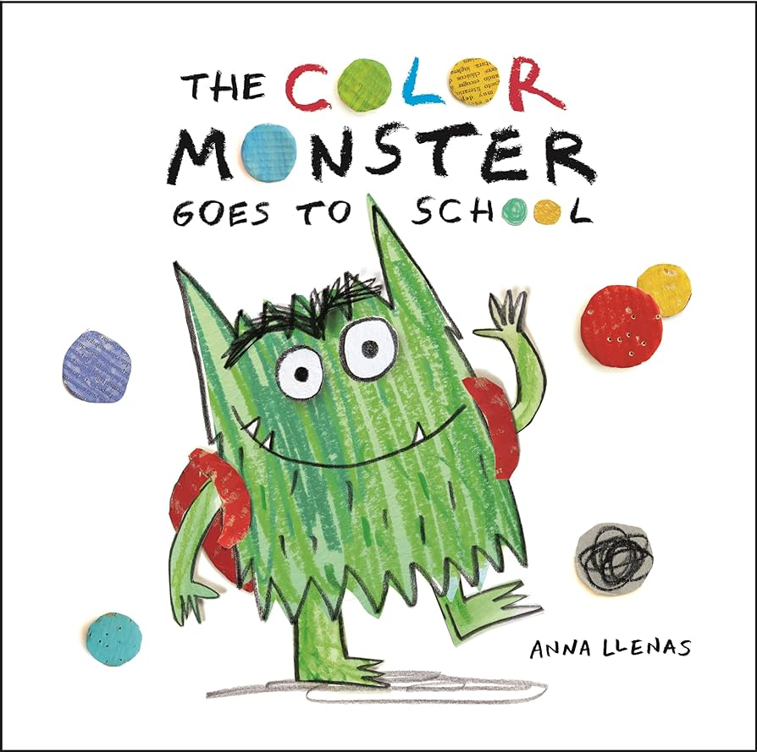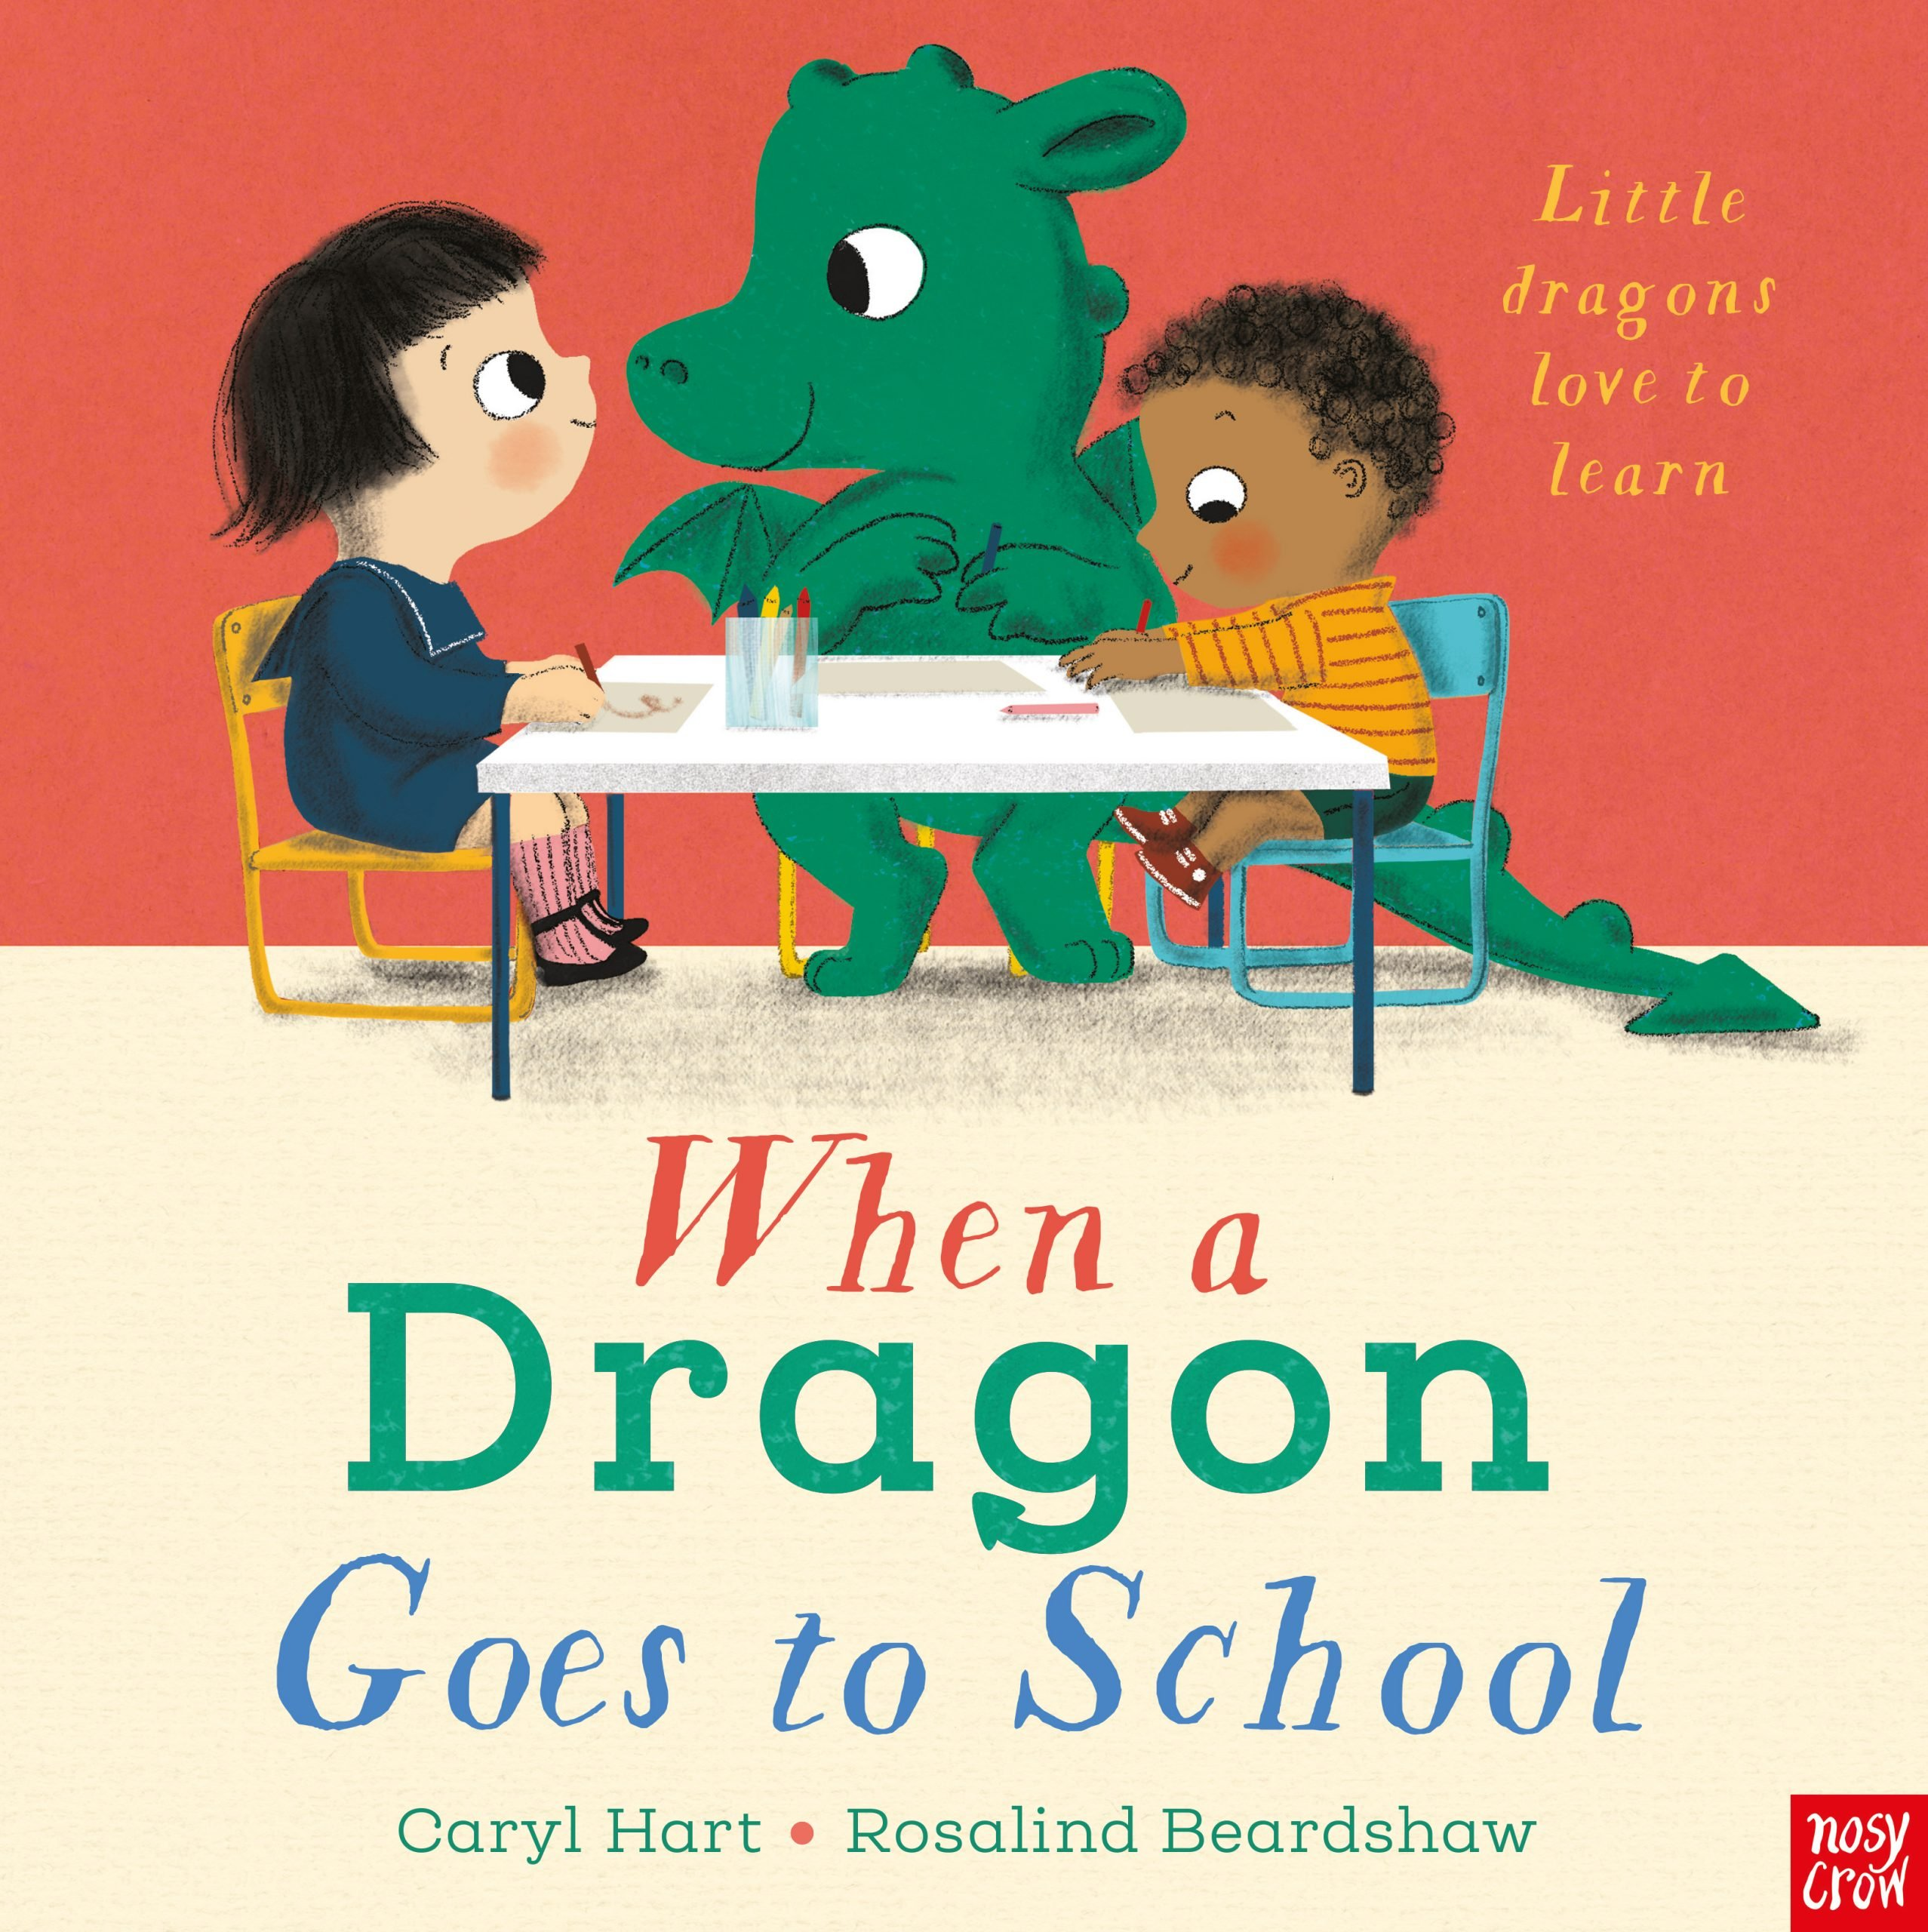

Nursery Knowledge Organiser Summer 2 – Changes
Phonics
We will continue to learn a letter sound each week. We will learn n, m, d, g, o, c, k
We will continue to practise our oral blending, alliteration and rhyme skills.

Key vocabulary –
Plant, seed, grow, life cycle. stem, leaves, petal #
Egg, caterpillar, chrysalis, cocoon, butterfly
Insects – ladybird, bee, ant, spider, worm
Change, melt, freeze

Key knowledge and skills this half term

Maths – 1:1 counting to 5, finger numbers to 5, recognise numerals to 5, count beyond 5, compare groups of objects (more/fewer), compare capacity (full, empty, half-full)

Language – Understand 2 part instructions, understand questions, hold a conversation, talk about stories.
Literacy – write some letters accurately, write some or all of name, recognise name, predict what may happen in a story.
Fine motor skills – Cut straight lines, attempt to cut shapes, use a comfortable pen grip with control, use a knife and fork.
Gross motor skills – attempt to skip, hop, stand on one leg, try to throw and catch a ball, pedal a bike, use a scooter.

Creative – Explore colour mixing, sing songs, show different emotions in artwork.

Personal, Social and Emotional Development – talk about own feelings and begin to have an awareness of others feelings, follow rules and understand why we have them, show more confidence in new social situations, start to understand the importance of tooth brushing and healthy eating.

