Our stories this term

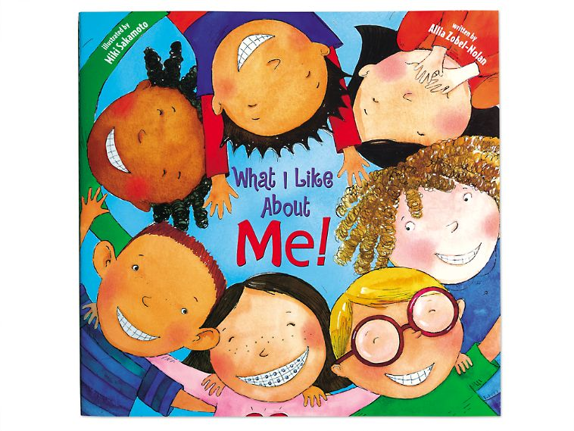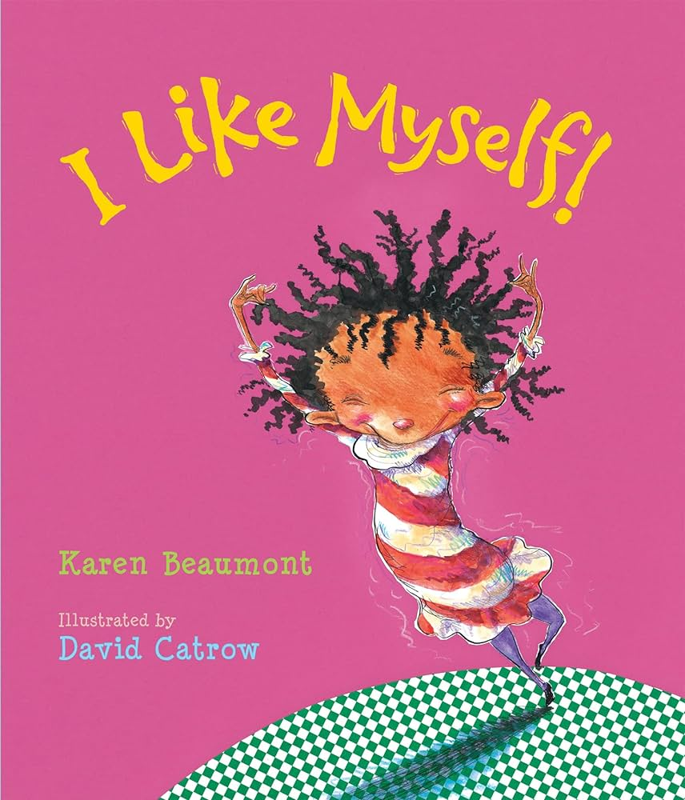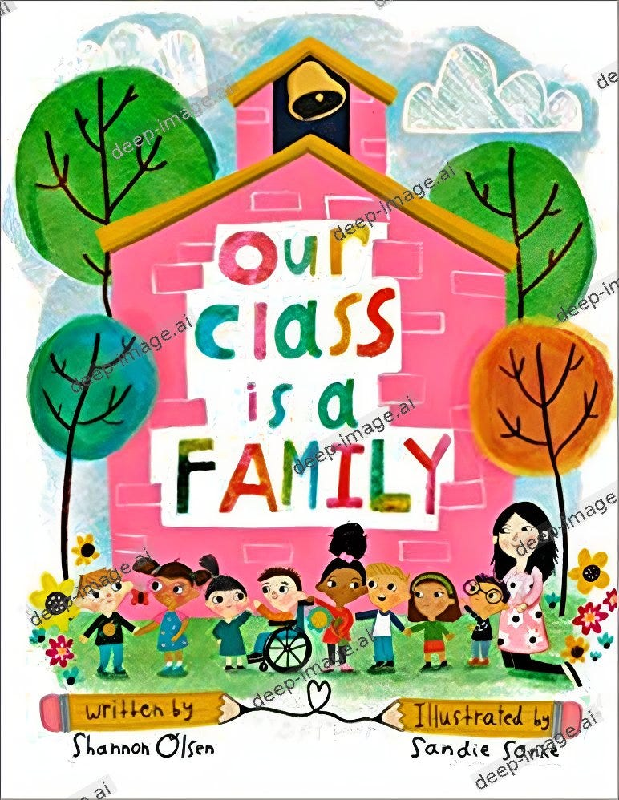
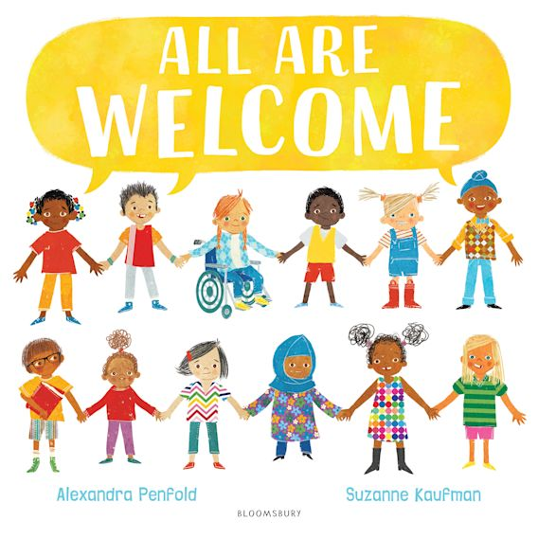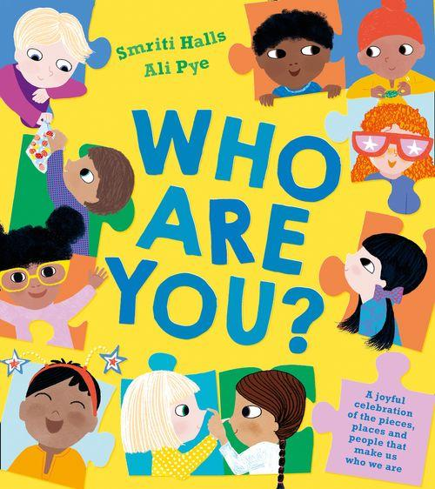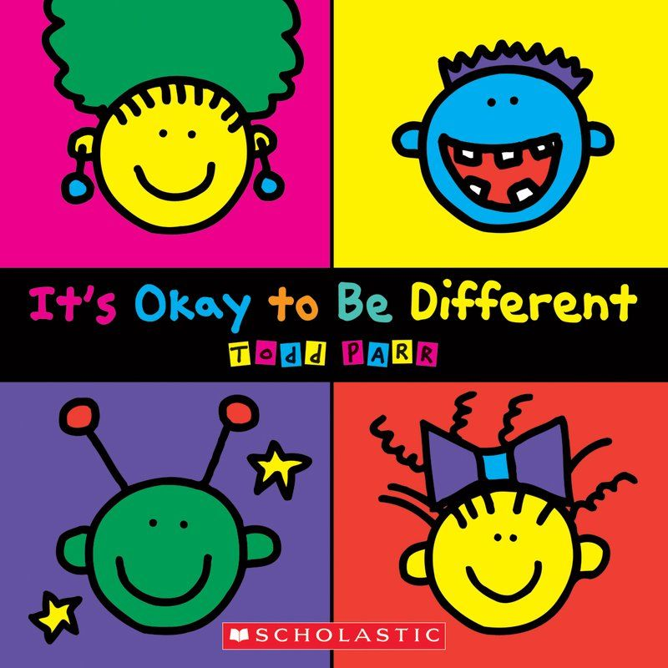

All about me
Key Knowledge
To know our facial features.
To talk about ourselves and our likes and interests.
To know we are all different and that’s ok!

Nursery Knowledge Organiser – Autumn 1 – All about me
Phonics
We will work on phase one phonics skills – these will be based around listening skills – making sounds with our voices and listening to different sounds.

Key vocabulary –
Face, eyes, ears, nose, mouth, chin, hair, teeth.
Hair, curly, straight, short. long
Different, unique, special

Key knowledge and skills this half term

Maths – daily counting and days of the week. Talking about how old we are.

Language – Uses different types of everyday words - nouns, verbs and adjectives. Joins in with songs and rhymes. Listen to simple stories with pictures.

Literacy – Draw a vertical and horizontal line and a circle. Handles book with care and holds the book the correct way up. Enjoy sharing a book with an adult. Pay attention and respond to the pictures or the words Join in with songs and rhymes.

Fine motor skills – Start using one handed tools eg paintbrushes/pens, Attempts to use scissors
Gross motor skills – Jump - Both feet off the floor, Build independently, Using shoulder and elbow movements to form lines or circles in the air with scarfs or ribbons

Creative – Explore paint , Make marks Explore sound makers. Enjoy action songs.

Understanding the world - Talk about own life story , Explore natural materials - wet/dry sand, water, paint, playdough etc

Simple pretend play

Personal, Social and Emotional Development – talk about own feelings and begin to have an awareness of others feelings, follow rules and understand why we have them, show more confidence in new social situations, start to understand the importance of tooth brushing and healthy eating.

