Long Term Plan - Vienna Base Class (Year 5 and 6)
 | Autumn 1 | Autumn 2 | Spring 1 | Spring 2 | Summer 1 | Summer 2
English Text | Arctic and Antarctic  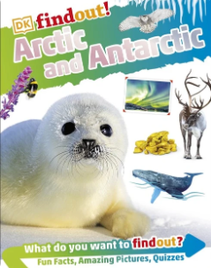 | The Lion, the Witch and the Wardrobe  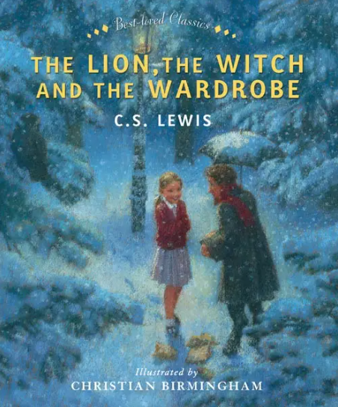 | Traditional Tales  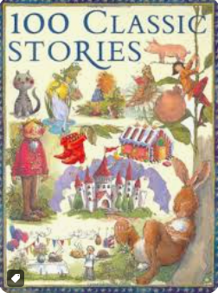 | Diary of a Killer Cat  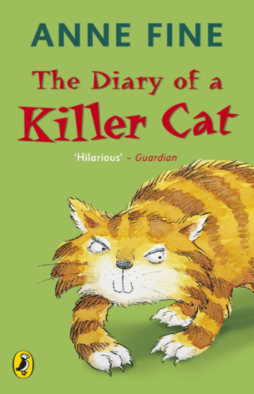 | See under the Sea  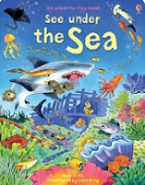 | Healthy Me: Keeping Safe 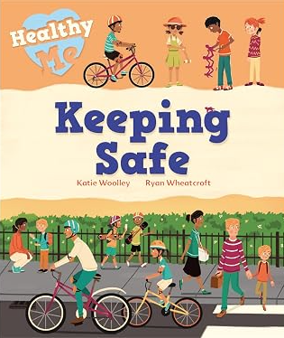
English | Writing to Explain  Comparison  Explanation Pamphlet  Poetic Forms | Writing to Persuade  Retelling of story from character’s perspective  Letter writing | Writing to Recount  Recount of traditional tales.  Diary entry  Recount of alternative ending  newspaper report  Classic Poetry | Writing to Entertain  Setting description  Character description  Innovated adventure story | Writing to Inform  Letter  Information leaflet  formal report | Writing to Inform  Factfile  Formal Report  Poetry
Phonics | Phase 5  Revision of previously taught Phase 5 GPCs  2 new GPCs  9 new HRS words | Phase 5  Revision of previously taught Phase 5 GPCs  2 new GPCs  9 new HRS words | Phase 5  Alternative spellings for previously taught sounds  49 new GPCs  4 new HRS words  Oral blending  Revision of Phase 2, Phase 3 and Phase 4 | Phase 5  Alternative spellings for previously taught sounds  49 new GPCs  4 new HRS words  Oral blending  Revision of Phase 2, Phase 3 and Phase 4 | All Phases  Revision of all previously taught GPCs for reading and spelling  Wider reading, spelling and writing curriculum | All Phases  Revision of all previously taught GPCs for reading and spelling  Wider reading, spelling and writing curriculum
Maths | *Place value  *Calculation  *Money  *Multiplication and division  *Measures | *Fractions  *Measures  *Shapes  *Angles  *Time | *Place value  *Calculation  *Money  *Multiplication and division  *Measures | *Fractions  *Measures  *Shapes  *Angles  *Time | *Place value  *Calculation  *Money  *Multiplication and division  *Measures | *Fractions  *Measures  *Shapes  *Angles  *Time
Motor Skills | Fine motor skills – Touch typing, handwriting, laces and buttons, zips.  paper craft, paint, textiles, sewing, threading, Thera putty.  Gross motor skills – dance, yoga, ball and racquet activities, obstacle course, playground equipment | Fine motor skills – Touch typing, handwriting, laces and buttons, zips.  paper craft, paint, textiles, sewing, threading, Thera putty.  Gross motor skills – dance, yoga, ball and racquet activities, obstacle course, playground equipment | Fine motor skills – Touch typing, handwriting, laces and buttons, zips.  paper craft, paint, textiles, sewing, threading, Thera putty.  Gross motor skills – dance, yoga, ball and racquet activities, obstacle course, playground equipment | Fine motor skills – Touch typing, handwriting, laces and buttons, zips.  paper craft, paint, textiles, sewing, threading, Thera putty.  Gross motor skills – dance, yoga, ball and racquet activities, obstacle course, playground equipment | Fine motor skills – Touch typing, handwriting, laces and buttons, zips.  paper craft, paint, textiles, sewing, threading, Thera putty.  Gross motor skills – dance, yoga, ball and racquet activities, obstacle course, playground equipment | Fine motor skills – Touch typing, handwriting, laces and buttons, zips.  paper craft, paint, textiles, sewing, threading, Thera putty.  Gross motor skills – dance, yoga, ball and racquet activities, obstacle course, playground equipment
Social Skills | Friendship | Perspectives | Emotions and the body | Emotions and the body | Travel Training (year 5).  Transition to High School (year 6). | Travel Training (year 5).  Transition to High School (year 6).
PSHE | Being Me in My World | Celebrating Difference | Dreams and Goals | Healthy Me | Relationships | Changing Me
Science | Light | Electricity | Animals incl. Humans | Animals incl. Humans | Living things & their Habitats | Living things and their Habitats

