 | Autumn 1 | Autumn 2 | Spring 1 | Spring 2 | Summer 1 | Summer 2
Upper Reception | Fairy tales  Three Billy Goats Gruff  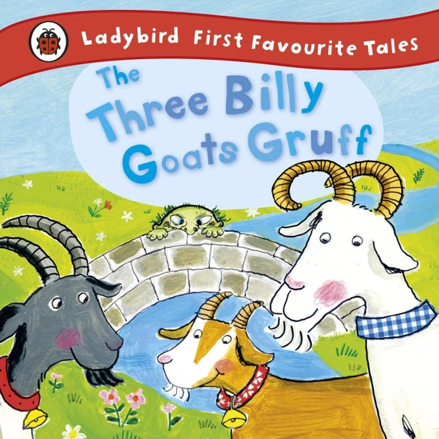  Jack and the Bean stalk  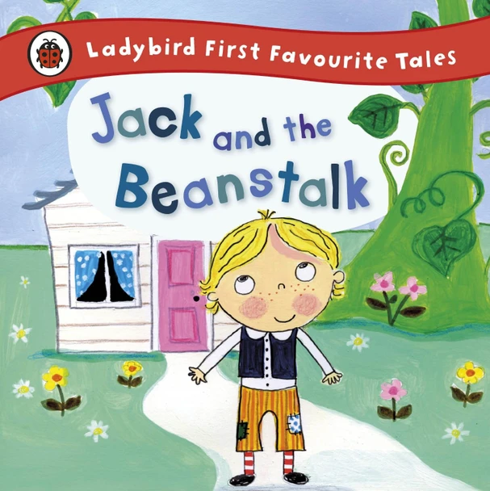 | Bears  Panda Big, Panda Small  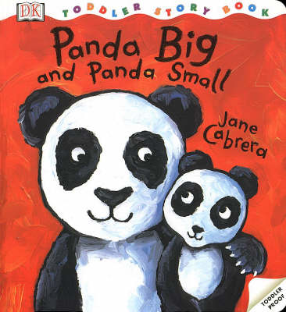  Scruffy Teddy loses his socks  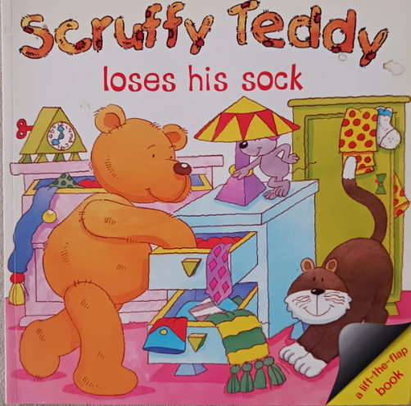 | Transport  Emergency vehicles- People who help me.  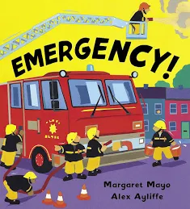  We all go travelling by  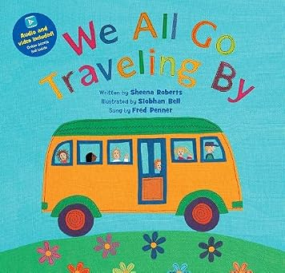  Please don’t chat to the bus driver  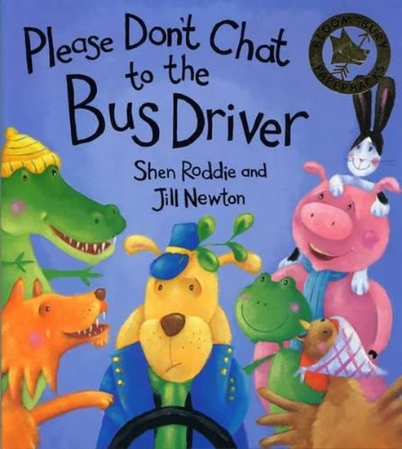 | Being Healthy  Eating Well  Healthy/Unhealthy  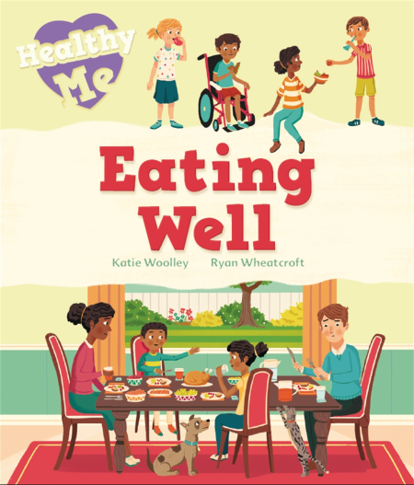  Keeping Safe  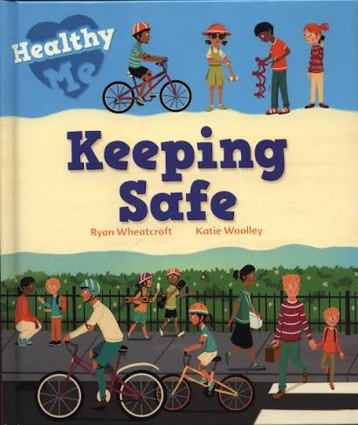  Resting and Sleeping  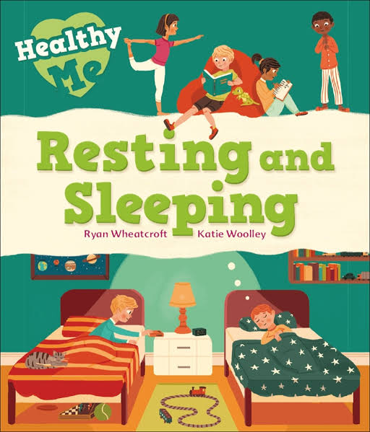 | Seaside  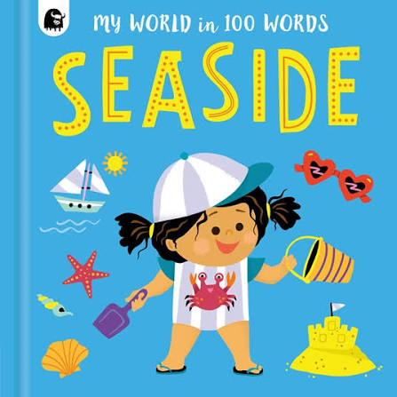  Clean Up!  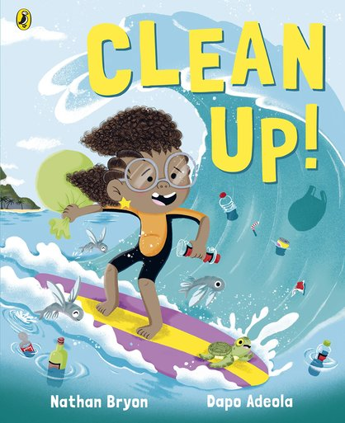  Let’s go to the seaside  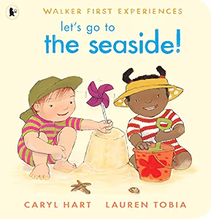 | Animals/Dinosaurs  Walking through the jungle  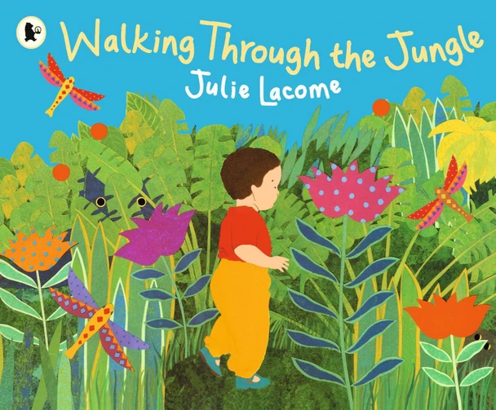  Hop on Top Mouse  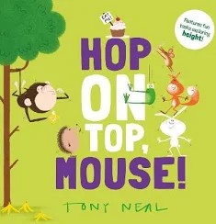
Year 1  &  Year 2 | The Elves and the shoemaker  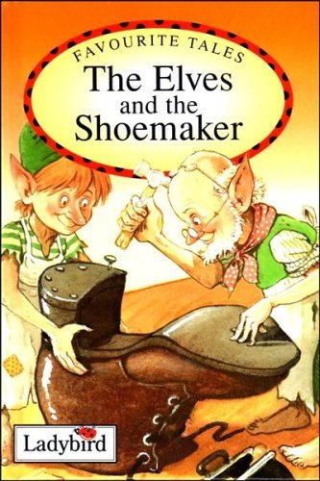  Where the wild things are  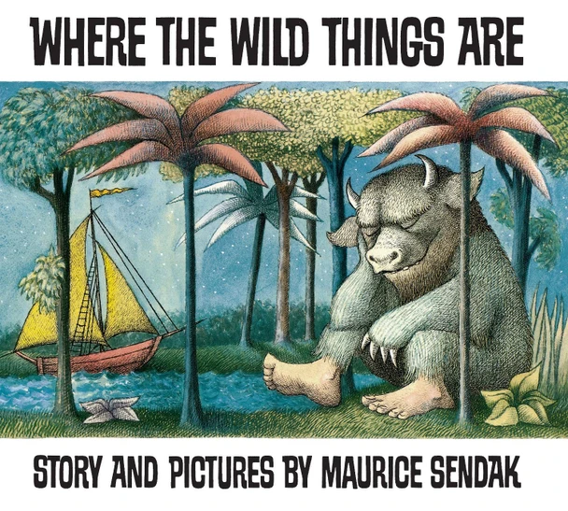  Three Billy Goats Gruff | All about Bears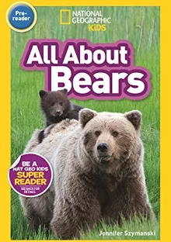  Boogie Bear David Walliams  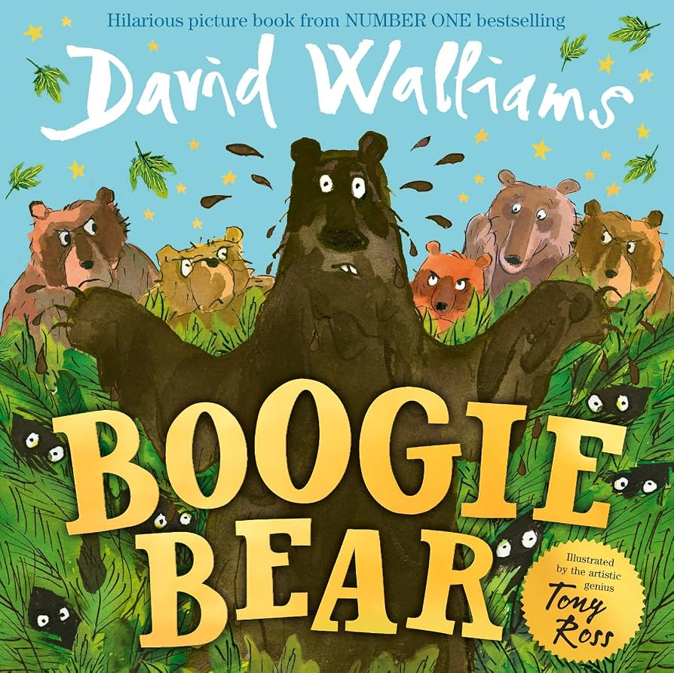  Little Polar Bears  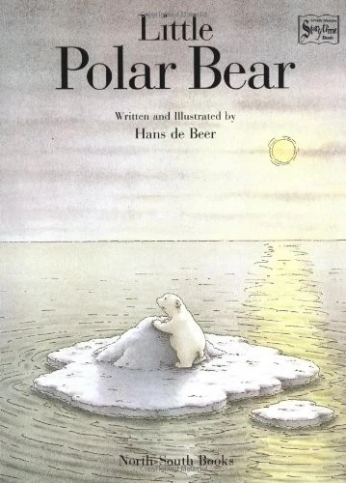 | The Energy Bus by Jon Gordon | Eating Well  Keeping Safe  Resting and Sleeping  Oliver’s Vegetables  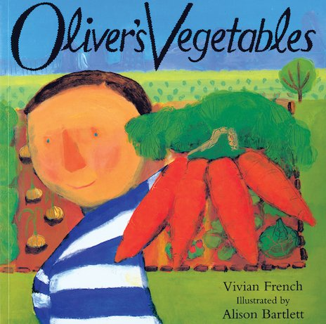 | Clean Up!  Dougal’s Deep Sea Diary  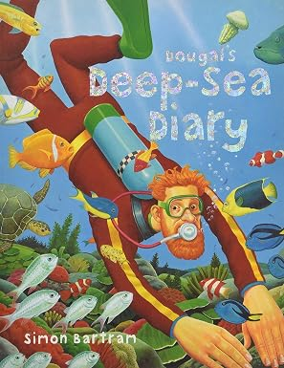 | Rainforest Animals  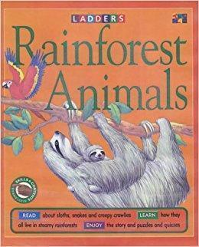  Dinosaurs  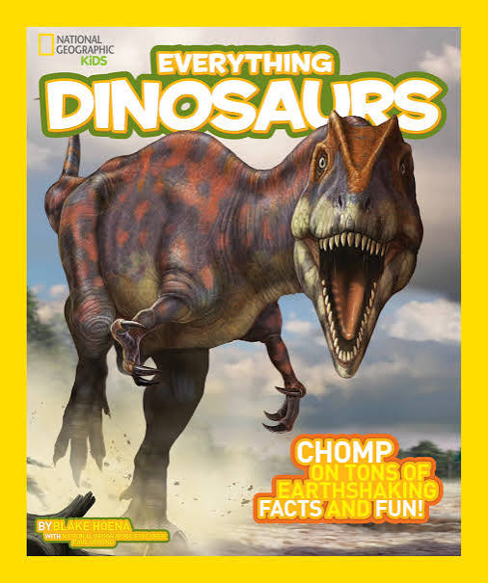
Phonics  Oxford  Owl  ELS |  | Phase 2  Oral blending  • Sounding out and blending with 23 new grapheme phoneme correspondences (GPCs)  • 12 new harder to read and spell (HRS) words | Phase 2  Oral blending  • Sounding out and blending with 23 new grapheme phoneme correspondences (GPCs)  • 12 new harder to read and spell (HRS) words | Phase 3  • Oral blending  • Sounding out and blending with 29 new GPCs  • 32 new HRS words  • Revision of Phase 2 | Phase 3  • Oral blending  • Sounding out and blending with 29 new GPCs  • 32 new HRS words  • Revision of Phase 2 | Phase 3  • Oral blending  • Sounding out and blending with 29 new GPCs  • 32 new HRS words  • Revision of Phase 2 | Phase 4  Oral blending  • No new GPCs  • No new HRS words  • Word structures – cvcc, ccvc, ccvcc, cccvc, cccvcc  • Suffixes  • Revision of Phase 2 and Phase 3
 | Maths (maths is on a spiral curriculum, meaning similar topics are revisited throughout the year so there aren’t such distinct topics each half term). | Place Value  Addition  Subtraction  Measuring length | Money  Addition and subtraction  Shape- 2D and 3D shapes and their properties  Time- o’clock, half past | Length, Mass, Volume and Capacity  Multiplication  Division  Addition and subtraction  Money | Fractions of an amount and shape  Position and direction  Statistics  Time  Shape | Place Value  Addition and subtraction  Multiplication and Division  Fraction of a shape and number | Shape  Directional turns  Capacity and mass

